Marconi 67 (1935)
Manufactured in Canada
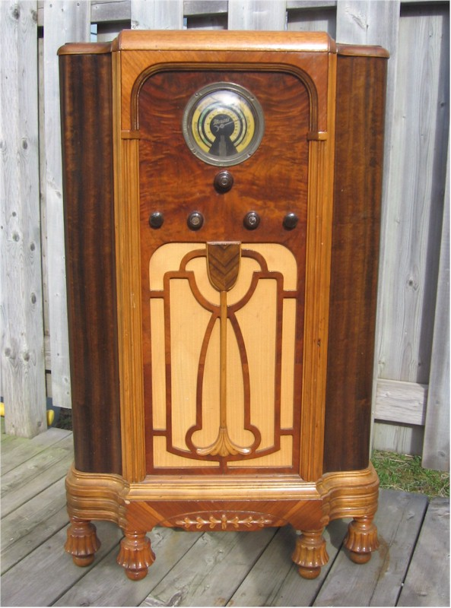Photo donated by Ken Walsh.
Marconi 67 part of the Jubilee series of 1935 which included Model 66, 67 and model 68. So named in honor of King George V Jubilee (Silver Anniversary) 25 years after taking the throne in 1910. Queen Elizabeth's II grandfather.

